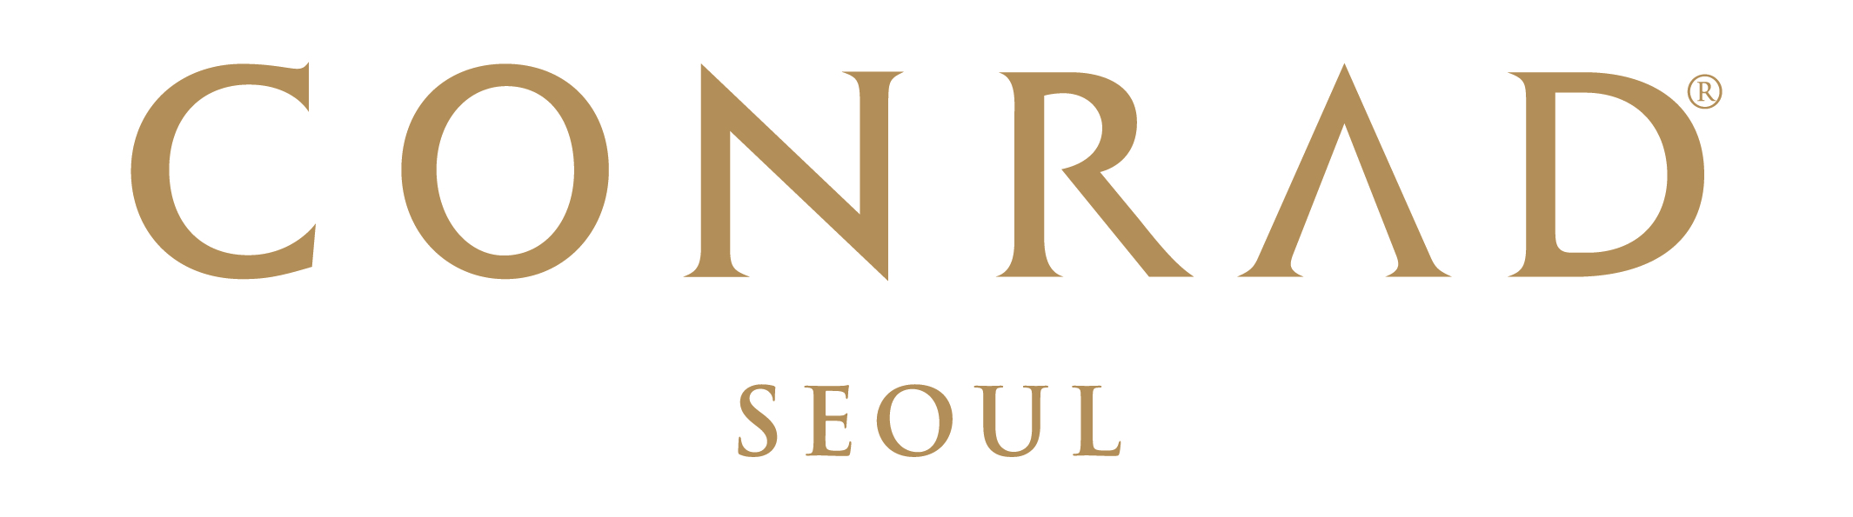  Conrad Seoul Reservation Form  ICOLA 2025  September 10, 2025 ~ September 13, 2025 | Conference Reservation  Conrad Seoul  10 Gukjegeumyung-ro (Yeouido),  Yeongdeungpo-gu, Seoul 07326, Korea  Phone:82-2-6137-7777  Email:  Conradseoul_GroupReservations@hilton.com

RESERVATION DETAILS
Check-in Date: |  |  |  |  |  |  |  | Arrival Flight: |  |  |  |  |  |  |  | ETA:
Check-out Date: |  |  |  |  |  |  |  | Departure Flight: |  |  |  |  |  |  |  | ETD:
Last Name: |  |  |  |  |  |  |  | First Name:
Company: |  |  |  |  |  |  |  | Title:
Booking Contact: |  |  |  |  |  |  |  | Phone:
Country: |  |  |  |  |  |  |  | Email:
Hilton Honors N.:
Room Type |  |  |  |  |  |  | Rate |  |  |  |  |  | Number of Rooms |  |  |  | Number of Adults/Children
 | Deluxe Room with Standard Internet |  |  |  |  |  | 15% Discount from the best available rate |  |  |  |  |  |  |  |  |  |  |  | /
*This special group rate for ICOLA 2025 is only available upon hotel’s availability and hotel may suggest a different room type depending on availability.
Preference: |  |  |  | Twin King
Remarks:
- All rates are subject to 10% VAT. No service charge will be applied.
- Special Breakfast charge is KRW 46,900 include 10% tax daily and can be added on-site if needed.
- And special rate will be offered for the participant of ICOLA 2025 from September 10, 2025 ~ September 13, 2025.
TRANSPORTATION
Limousine Transfer Required: |  |  | -Airport pick up & sending service to Conrad Seoul & Incheon International Airport : KRW 225,000 per car (subject to 10% tax)  -Any cancellations or amendments must be received at least 24 hours prior to the expected arrival date |  |  |  |  |  |  |  |  |  |  | Arrival |  |  |  | Departure
RESERVATION GUARANTEE
A credit card guarantee is required at the point of reservation. Reservation can be cancelled or amended 7 days prior to the event date Entire period of stay will be charged before arrival and incidental will be charged upon check-out.
Guaranteed by: |  |  |  |  | Credit Card:
Cardholder’s Name: |  |  |  |  |  |  |  |  |  | Signature:
Credit Card Number: |  |  |  |  |  |  |  |  |  | Expiry Date:

CANCELLATION POLICY
Reservation can be changed or amended 7 days prior to the event date.
Any cancellations or no shows after 7 days to the event date will be charged the entire period of stay.

TERMS AND CONDITIONS
- To enjoy the room block of ICOLA 2025, guest rooms will be provided with special rate upon hotel availability.
- Reservation received thereafter will be confirmed subject to availability at prevailing rates.
- Check-in time is after 16:00pm. Check-out time is before 11:00am. For any guests who would like immediate guaranteed access to their rooms prior to 16:00 PM check-in time, the room should be reserved from the previous evening. This will incur an additional one-night accommodation charge.
- This form must reach the hotel no later than 3rd September, 2025.
- By providing above mentioned credit card details, cardholder agrees to the reservation guarantee policy.
- Hilton Honors members are entitled to earn hotel points. To enroll, please visit www.hiltonhonors.com.

